Lab Practice-7

Submission Guidelines-
- Rename the file with your serial number only
- Must submit within time that will be discussed in class VUES
- Must include resources for all the section in the table
Question-
Create a simple day and night scenario that will automatically change from day to night

Graph
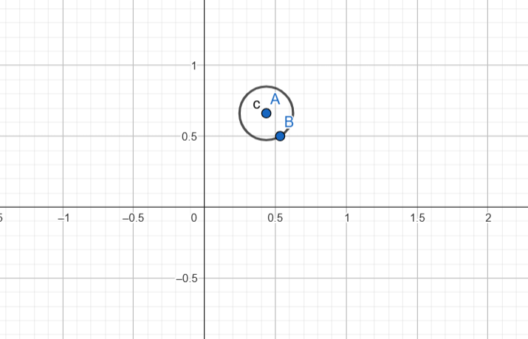
Code-
#include <GL/glut.h>
#include <cmath>
using namespace std;

bool isDay = true; // Start with day

void drawCircle(float x, float y, float radius) {
int triangleAmount = 50;
float twicePi = 2.0f * 3.1416f;

glBegin(GL_TRIANGLE_FAN);
for(int i = 0; i <= triangleAmount; ++i) {
glVertex2f(
x + (radius * cos(i * twicePi / triangleAmount)),
y + (radius * sin(i * twicePi / triangleAmount))
);
}
glEnd();
}

void display() {
glClear(GL_COLOR_BUFFER_BIT);

// Set background color
if (isDay) {
glClearColor(0.5f, 0.8f, 1.0f, 1.0f); // Day: sky blue
} else {
glClearColor(0.0f, 0.0f, 0.2f, 1.0f); // Night: dark blue
}
glClear(GL_COLOR_BUFFER_BIT);

// Draw sun or moon
if (isDay) {
glColor3f(1.0f, 1.0f, 0.0f); // Yellow sun
} else {
glColor3f(1.0f, 1.0f, 1.0f); // White moon
}

drawCircle(0.7f, 0.7f, 0.1f); // Static position in top-right

glutSwapBuffers();
}

void timer(int value) {
isDay = !isDay; // Toggle day/night
glutPostRedisplay(); // Redraw screen
glutTimerFunc(3000, timer, 0); // Call again after 3 seconds
}

void init() {
glMatrixMode(GL_PROJECTION);
gluOrtho2D(-1, 1, -1, 1); // 2D coordinate system
}

int main(int argc, char** argv) {
glutInit(&argc, argv);
glutInitDisplayMode(GLUT_DOUBLE | GLUT_RGB);
glutInitWindowSize(800, 600);
glutCreateWindow("Static Day and Night Scene");

init();
glutDisplayFunc(display);
glutTimerFunc(0, timer, 0);
glutMainLoop();

return 0;
}

Output Screenshot (Full Screen)-
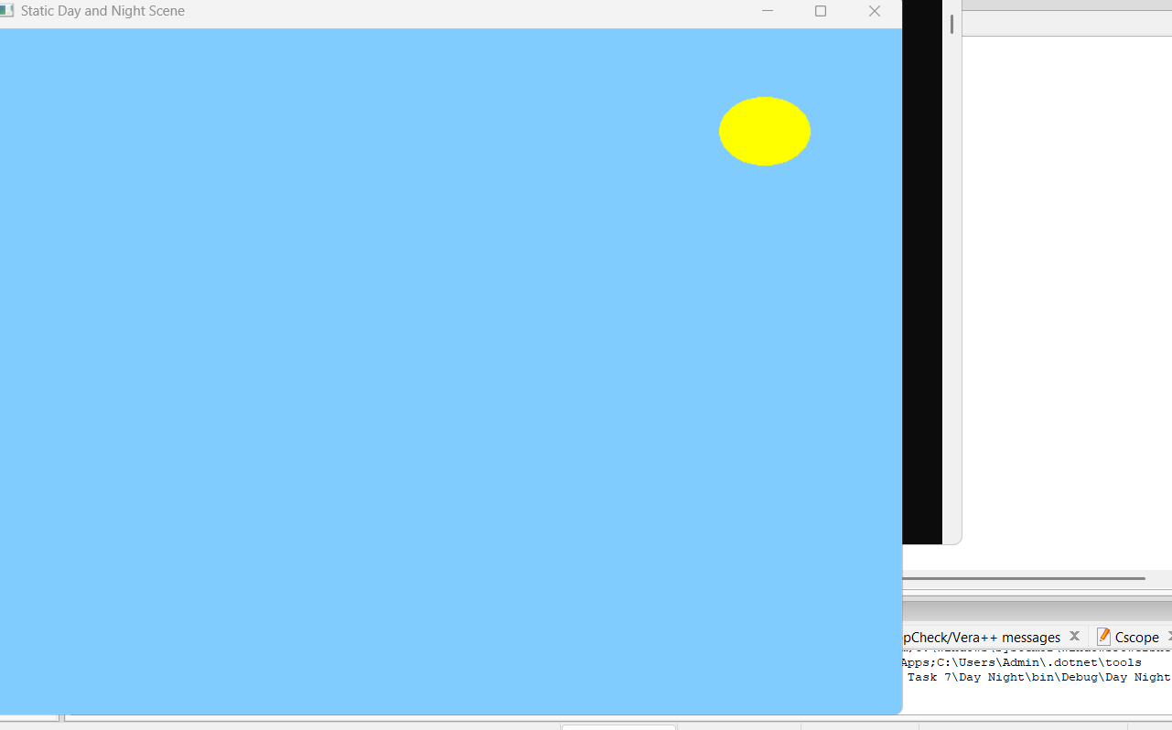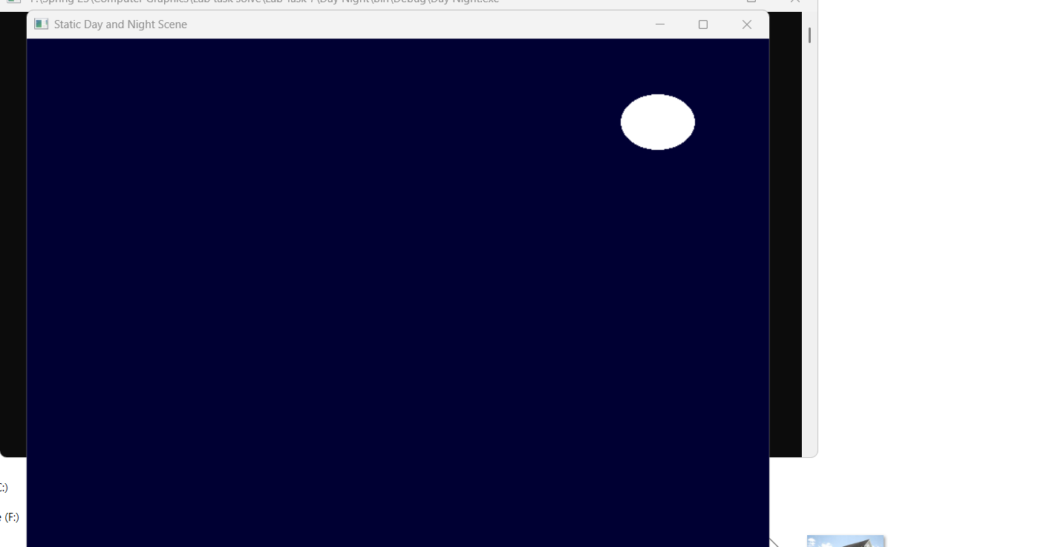

Question-
Create a simple day and night scenario using keyboard interaction. The key ‘D’ or ‘d’ will initiate the day mode and the key ‘N’ or ‘n’ will initiate the night mode.

Graph

Code-
#include <GL/glut.h>
#include <cmath>
using namespace std;

bool isDay = true; // Start with day

void drawCircle(float x, float y, float radius) {
int triangleAmount = 50;
float twicePi = 2.0f * 3.1416f;

glBegin(GL_TRIANGLE_FAN);
for(int i = 0; i <= triangleAmount; ++i) {
glVertex2f(
x + (radius * cos(i * twicePi / triangleAmount)),
y + (radius * sin(i * twicePi / triangleAmount))
);
}
glEnd();
}

void display() {
glClear(GL_COLOR_BUFFER_BIT);

// Background
if (isDay)
glClearColor(0.5f, 0.8f, 1.0f, 1.0f); // Day
else
glClearColor(0.0f, 0.0f, 0.2f, 1.0f); // Night

glClear(GL_COLOR_BUFFER_BIT);

// Sun or Moon
if (isDay)
glColor3f(1.0f, 1.0f, 0.0f); // Sun (yellow)
else
glColor3f(1.0f, 1.0f, 1.0f); // Moon (white)

drawCircle(0.7f, 0.7f, 0.1f); // Static top-right

glutSwapBuffers();
}

void handleKeypress(unsigned char key, int x, int y) {
if (key == 'd' || key == 'D') {
isDay = true;
} else if (key == 'n' || key == 'N') {
isDay = false;
}
glutPostRedisplay(); // Redraw the scene
}

void init() {
glMatrixMode(GL_PROJECTION);
gluOrtho2D(-1, 1, -1, 1); // 2D view
}

int main(int argc, char** argv) {
glutInit(&argc, argv);
glutInitDisplayMode(GLUT_DOUBLE | GLUT_RGB);
glutInitWindowSize(800, 600);
glutCreateWindow("Day and Night Mode Switch");

init();
glutDisplayFunc(display);
glutKeyboardFunc(handleKeypress); // Handle D/d/N/n keys
glutMainLoop();

return 0;
}

Output Screenshot (Full Screen)-



